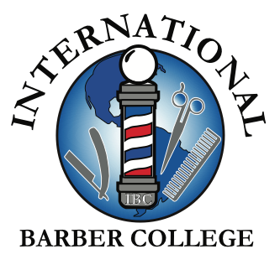

PRICES FOR BARBER SCHOOL
Application Fee: $50.00
Registration Fee: $75.00
Tool Kit: $1,500.00
TUITION: $16,000.00
TOTAL: $17,625.00

PRICES FOR COSMETOLOGY CROSSOVER
Application Fee: $50.00
Registration Fee: $75.00
Tool Kit: $1,500
TUITION: $7,995
TOTAL: $9,620

