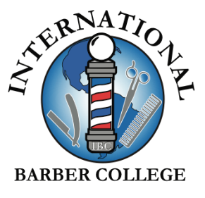

LETTER OF INTENT & MUTUAL INTERVIEW PROCESS INFORMATION
Congratulations! You have chosen to take the first step towards pursuing an amazing career as a future successful Barber and we are honored that you have chosen to discuss your future with us here, at the International Barber College.
We want to make sure that every potential future student applicant is aware of what we are looking for when we read the Letter of Intent. You see, we don’t believe in a tour & enroll process, we strongly believe in providing a mutual interview process. We want to make sure that everybody is aware of the International Barber College’s culture, policies, rules, schedules, prior to the first appointment scheduled.
We provide all of the financial aid education and resources in the first e-mail as well, so the applicant is aware of tuition and what resources are potentially available (please note: the International Barber College and all affiliated are not responsible for the applicant’s financial aid application or the results.)
We provide the class schedules and holiday schedules, so the applicant is aware of what flexible schedule options we have available as well as what the contract student class schedule policies are, and what holidays the International Barber College is closed in effort for the applicant to schedule their future vacation time accordingly, prior to the first appointment.
The Letter of Intent is an opportunity for the International Barber College to get to know the applicant for their goals, their passions, reasons why they feel they must be a part of the Barbering Industry, what motivated the applicant to get started on this long time career goal as well as what has prevented them in the past to get started, and foreseeing any future struggles that can create a hurdle that prevents them from reaching their potential graduation day.
This gives the applicant a moment to reflect on the history of this career goal, how serious they are, if they’re truly ready to start, and if there is a potential obstacle that can derail the applicant from success that if they really want to start on the date discussed, this will also give them an opportunity to create resolutions and preventatives prior to the issue occurring.
We are providing a foundation of education and entrepreneurship training and it all starts even before the applicant steps foot into the International Barber College for their first appointment. We provide this mutual interview process to ensure that it will be an incredible mutual fit for the potential barber student as well as the International Barber College. Which is again why, the applicant must comply with all the above mentioned routine so if the applicant see’s that a schedule, policy, or any other detail may not be a good fit for them then we must prevent any chance of failure and notice whether or not that detail will be a mutual good fit or not, prior to the first scheduled appointment.
Below are the details of what to include in your Letter of Intent (of course, in addition to anything else you would like to share)
Please take your time when writing this Letter of Intent and give it your all as this is a part of the mutual interview process. Please note on the “Enrollment Checklist” number 8 states: “Letter of Intent: Explaining why you have chosen a career in the Barbering Industry, what your career goals are, why you have chosen the International Barber College, any potential hurdles that can prevent you from successfully completing your education with the International Barber College, and why you feel you are a good fit for the International Barber College. “

